Microsoft SQL Server Installation Guide
SQL Server 2022 Developer Edition

Hongyu Guo
September 2025

Downloading SQL Server Installer
You will find the Developer edition download from the Microsoft SQL Server download site.
https://www.microsoft.com/en-ca/sql-server/sql-server-downloads
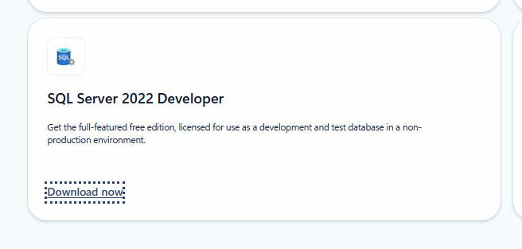

After the download is complete, navigate to the destination folder (e.g., your Downloads folder). Locate the installer file, right-click it, and select “Run as administrator” to begin the installation.

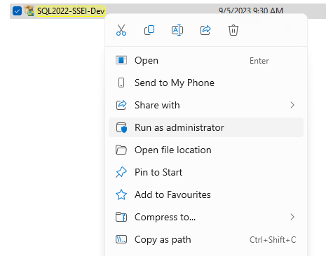

Installing SQL Server Developer Edition
1. Once the installation starts, you will be presented with installation type. We will focus on the Custom install and explain various features of the installation.
2. Once the SQL Server Installation Center launches choose Installation tab and select ‘New SQL Serverstandalone installation or add features to an existing installation’.

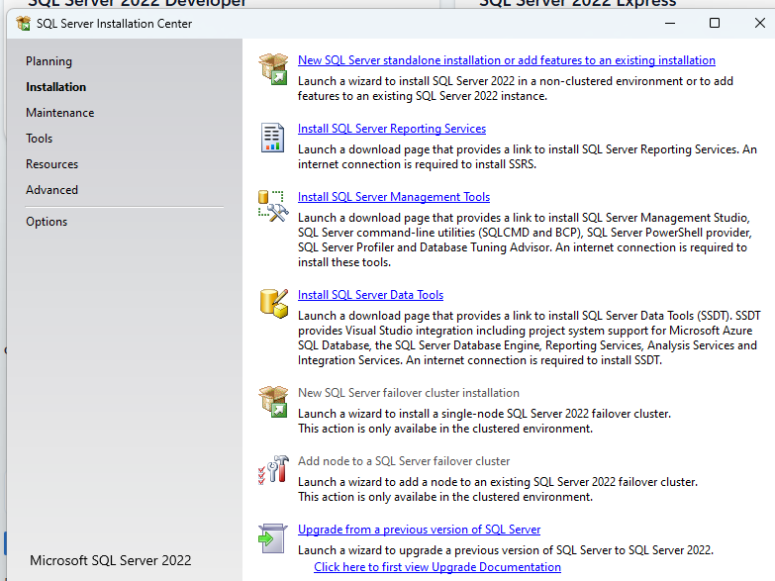

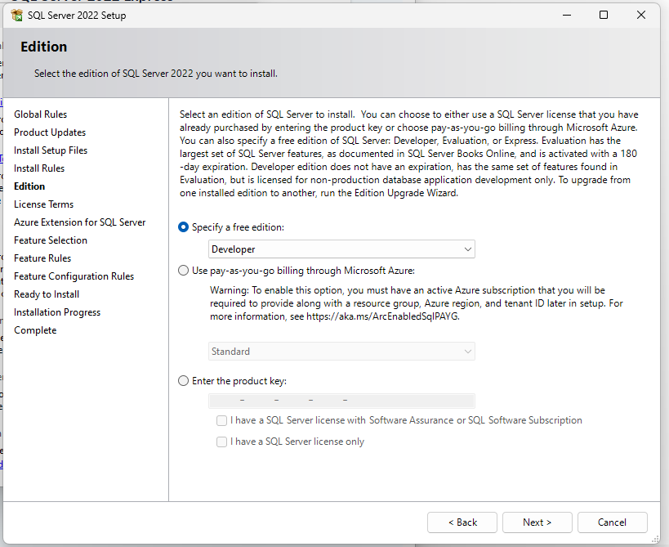
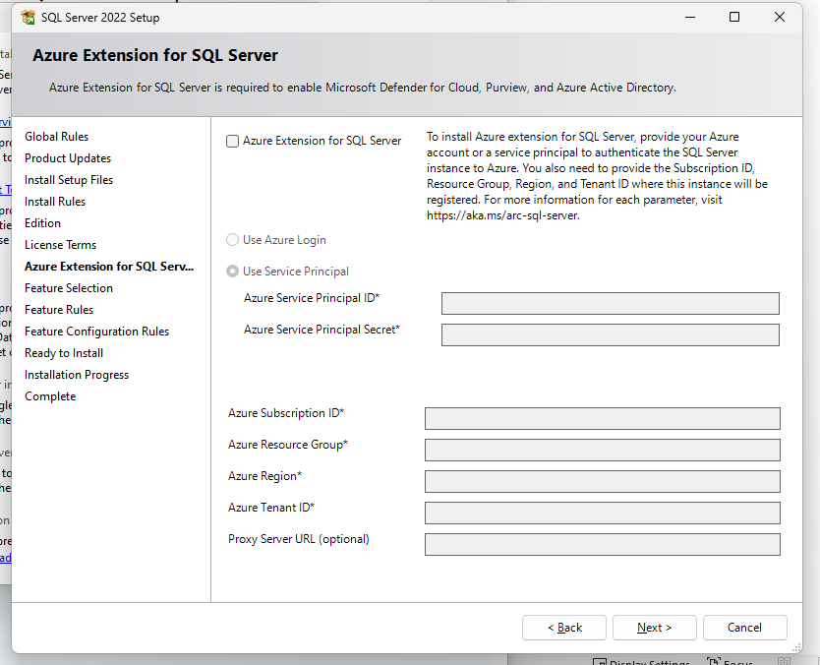
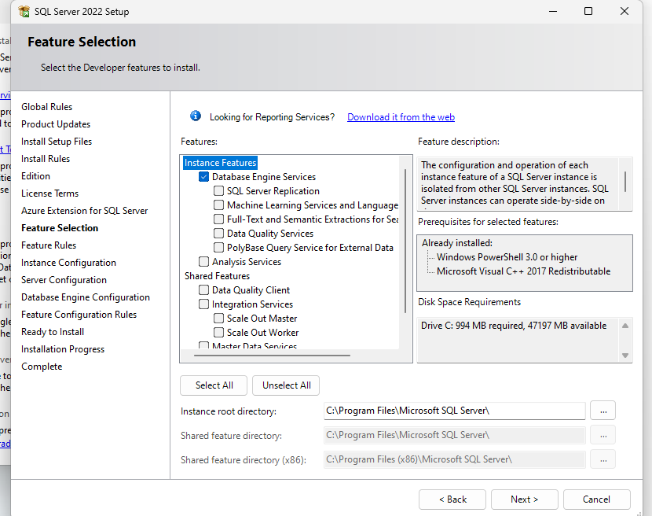
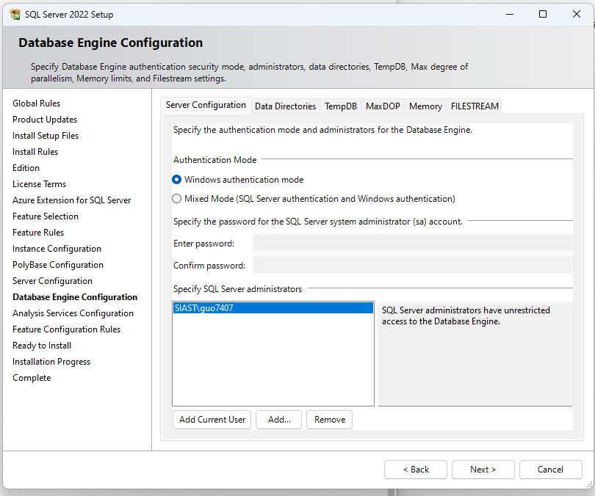

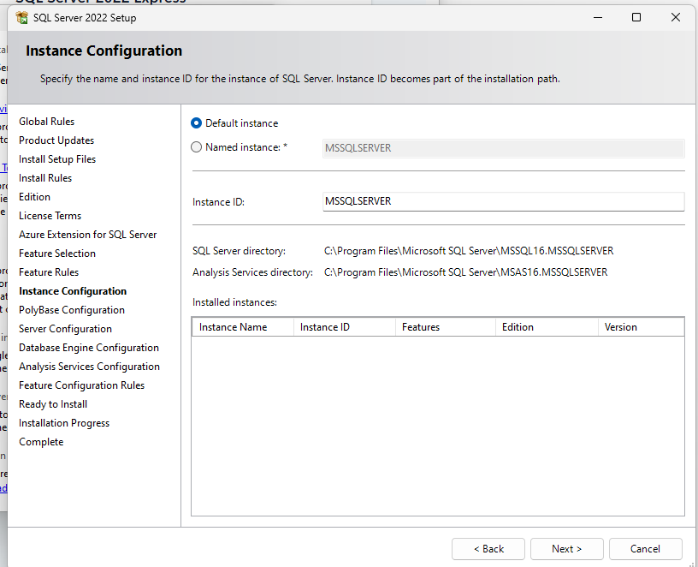

Install SQL Server Management Studio (SSMS)
1. Run the SSMS installer as Administrator.
2. Follow the on-screen instructions and complete the installation.
3. Once installed, open SSMS from the Start Menu.

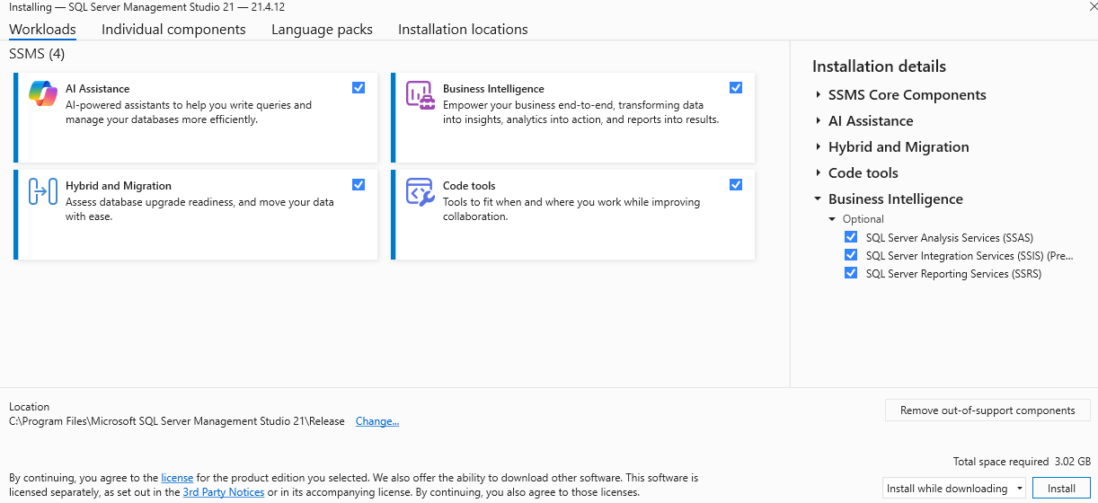

Connecting to SQL Server
1. Open SSMS.
2. In the 'Connect to Server' window:
- Server type: Database Engine
- Server name: localhost (or simply a dot '.')
- Authentication:
* Windows Authentication (use your Windows account)
* Or SQL Server Authentication (if you set up 'sa' user in Custom install)
3. Click Connect.
4. If successful, you can now create databases and run SQL queries.

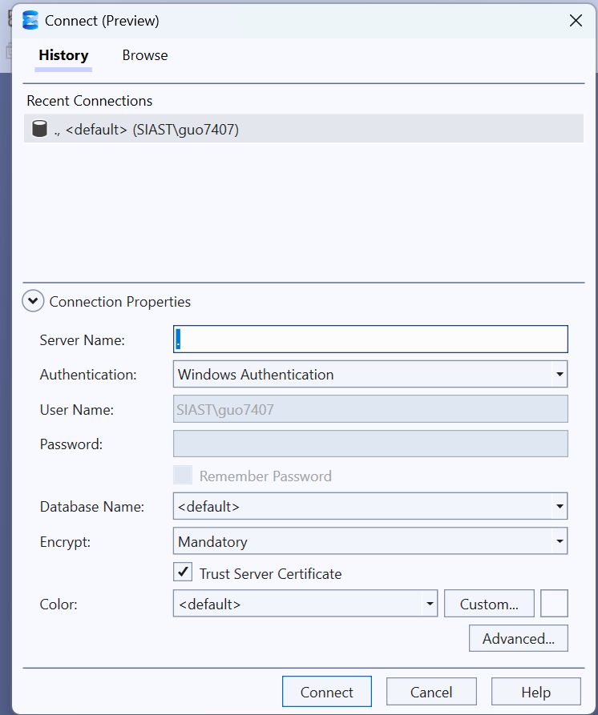

Creating a Database
1. Right-click on Databases in the Object Explorer and click New Database…
2. Enter a database name (e.g., CDBM603) and click OK.
3. Expand Databases and locate your new database.
4. Right-click on your database and select New Query.
5. Type and execute: SELECT DB_NAME() as DatabaseName
6. You should see the results with your database name.

